# **Phase 1: Problem Understanding & Industry Analysis**

👉To clearly define the purpose of the project by understanding the problem it aims to solve, identifying the needs of stakeholders, and outlining the objectives of building the Patient Appointment Chatbot CRM.

## **Requirement Gathering**

The project began with discussions with hospital staff, doctors, and patients to identify key challenges in appointment management.

**Key Requirements identified:**

* Patients should be able to easily book, reschedule, or cancel appointments.
* Doctors need a clear view of their schedules and patient medical history.
* Automated SMS/Email reminders must reduce no-shows.
* Hospital administrators should access dashboards for performance monitoring.
* Secure storage of patient medical data with access control.

**Stakeholder Analysis**

**Patients** – Need quick booking, reminders, and prescription access.

**Doctors** – Require organized schedules and patient history.

**Receptionists** – Manage bookings and prevent double-booking errors.

**Administrators** – Monitor doctor utilization, no-shows, and efficiency.

**IT Team** – Ensure system scalability, security, and integrations.

## **Business Process Mapping**

Flow of how things will work :

**Patient books appointment via portal/chatbot → System checks doctor availability → Appointment__c created → Automatic confirmation (Email/SMS) → Reminders sent → Doctor accesses appointment list + patient history → Admins view reports/dashboards**.

## **Industry-Specific Use Case Analysis**

* Automates and reduces manual effort.
* Enhances patient–doctor engagement.
* Provides transparent dashboards.
* Ensures secure and compliant data handling.

## **AppExchange Exploration**

During project planning, existing Salesforce healthcare solutions were studied for inspiration:

1. **Salesforce Health Cloud** – Comprehensive healthcare CRM.
2. **Twilio SMS Integration** – For sending appointment reminders.
3. **FormAssembly / Web-to-Lead** – For capturing patient details from web forms.
4. **Einstein Bot** – Chatbot for conversational booking and FAQs.

These helped design the project’s unique combination of **custom objects + chatbot + dashboards**.

**Workflow Diagram**

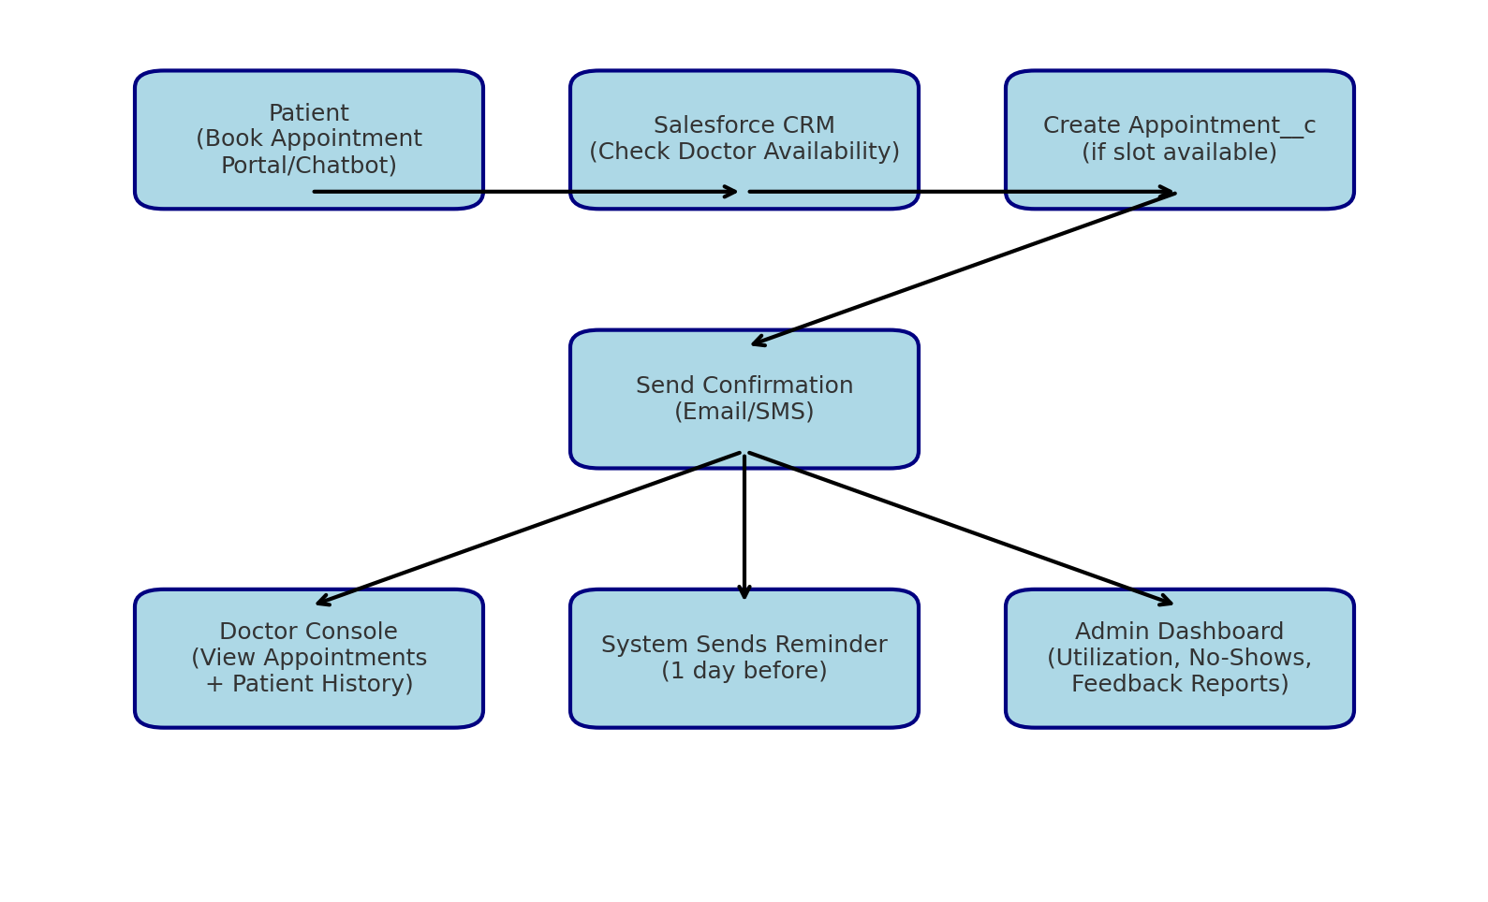

# **📄 Phase 2: Org Setup & Configuration**

👉 **Goal:** To set up the Salesforce org environment, define company structure, roles, and permissions to support the Real Estate Lead Management System.

## **Org Setup**

* Chose **Salesforce Enterprise Edition** (Health Cloud optional).
* Configured **company profile**: hospital name, address, fiscal year, business hours, and holidays.
* Created **custom apps & tabs** for Patients, Doctors, Appointments, and Prescriptions.

## **Role Hierarchy**

Designed to ensure **secure and structured access**:

* **Hospital Administrator** → Full access to all records and dashboards.
* **Doctors** → Access to their appointments and patients only.
* **Receptionists** → Access to booking and appointment scheduling.
* **Patients (Community Users)** → Access only to their personal information and bookings.

## **Profiles & Permission Sets**

* **Profiles:**
  + *System Administrator* → Full access.
  + *Doctor Profile* → Read/write access to Appointment__c, Prescription__c.
  + *Receptionist Profile* → Create/read appointments, limited edit rights.
  + *Patient Profile* → Read-only for their own records.
* **Permission Sets:**
  + Extended access for specific scenarios (e.g., IT staff monitoring system logs, chatbot integration permissions).

## **Users**

Created sample **users for each profile**:

* *Admin User* – Full control.
* *Doctor User* – Assigned by specialization (Cardiology, Pediatrics, etc.).
* *Receptionist User* – Appointment management.
* *Patient User* – Community access for self-service booking.

Used gmail plus-addressing for test accounts([e.g.rakshita.gupta.aiml22517@agentforce.com](mailto:e.g.rakshita.gupta.aiml22517@agentforce.com)).

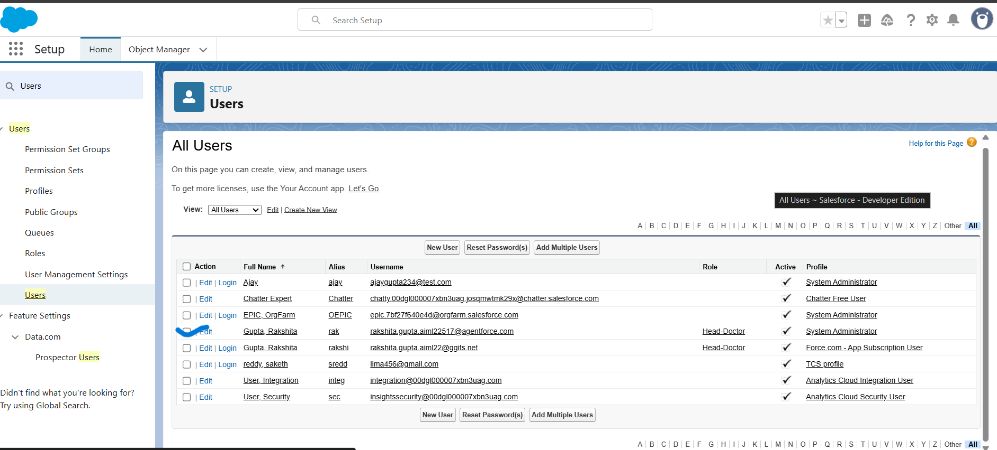

## **Short Description**

This phase focused on configuring the Salesforce environment to match hospital operations. It established **secure data access**, role-based hierarchies, and user management to ensure that each stakeholder interacts with the system according to their responsibilities.

✅ **Outcome of Phase 2:**

* Hospital CRM org configured successfully.
* Role-based access control implemented.
* Users assigned correct profiles and permissions.
* Ready for data modeling and automation in subsequent phases.

**Workflow Diagram**

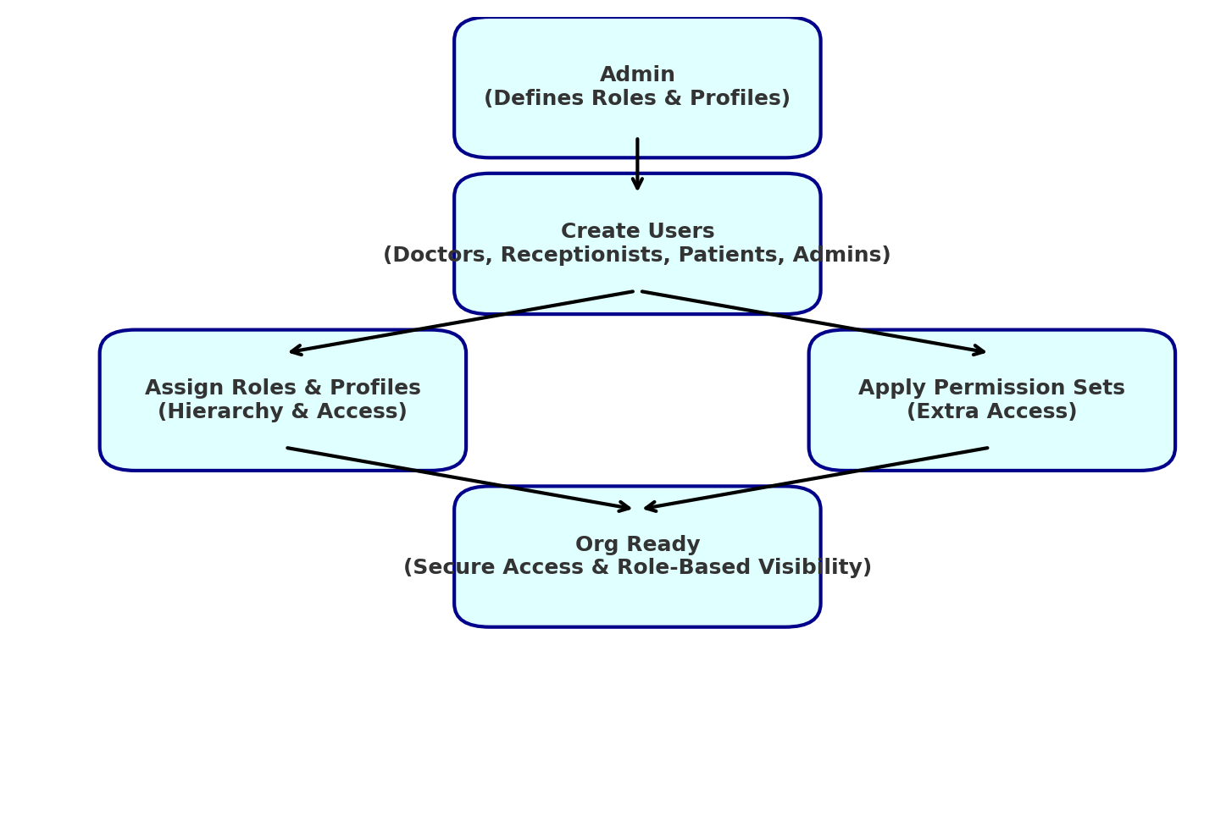

# **📄 Phase 3: Data Modeling & Relationships**

👉 **Goal:** To design a scalable and secure data model that captures patients, doctors, appointments, and prescriptions to support hospital workflows.

## **Requirement Gathering for Data Model**

* Capture **Patient details** (name, age, gender, contact, medical history).
* Maintain **Doctor profiles** (specialization, availability, contact info).
* Store **Appointment details** (date, time, doctor, patient, status).
* Track **Prescriptions** linked to each appointment.

**Objects & Fields**

**1 . Patient__c**

* FirstName , LastName, DOB, Phone , Medical_History

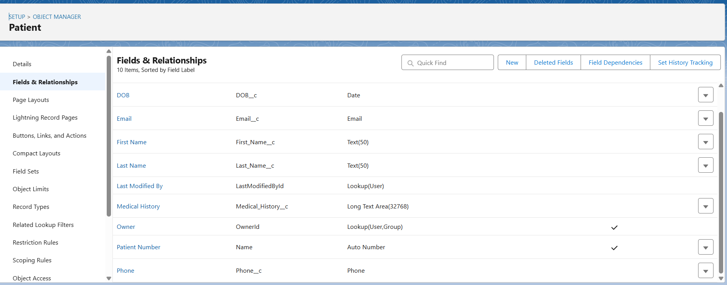

**2. Doctor__c**

* Name, Specialization, Work Start Time,Work End Time.

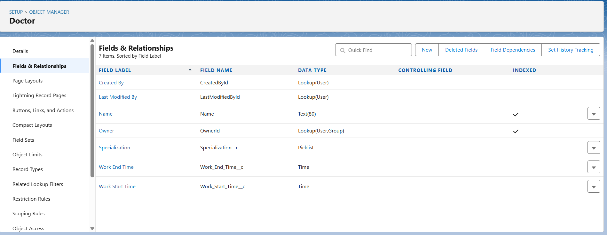

**3. Appointment__c**

* Appointment_DateTime, Status,Visit Type,Notes,Shared_with_Doctor__c Patient__c (Lookup), Doctor__c (Lookup)

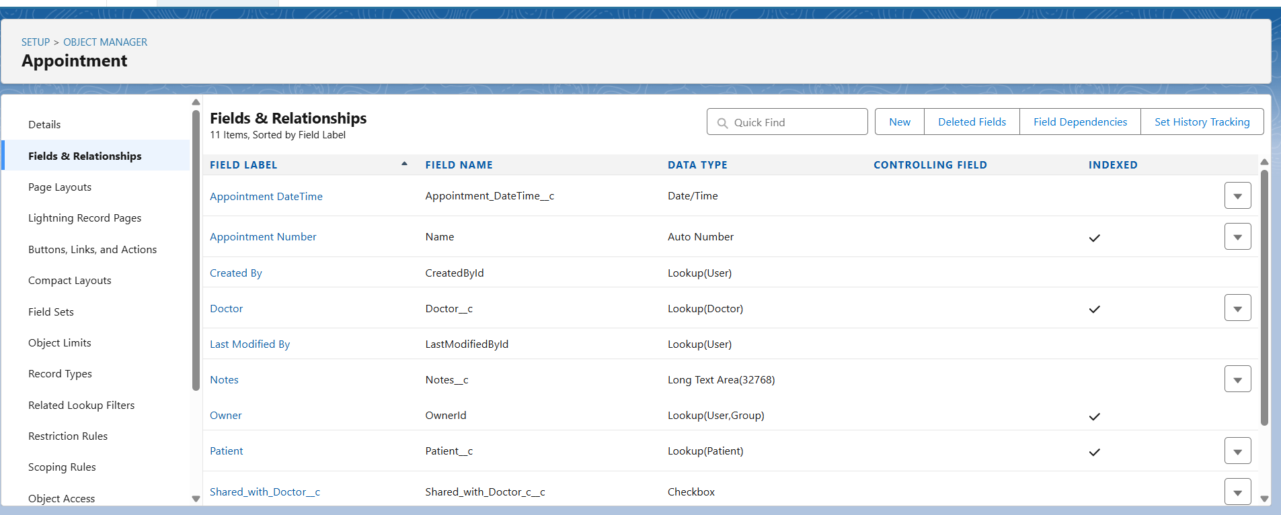

**4. Prescription__c**

* Medicine__c, Dosage__c, Linked Appointment__c (Master-Detail)

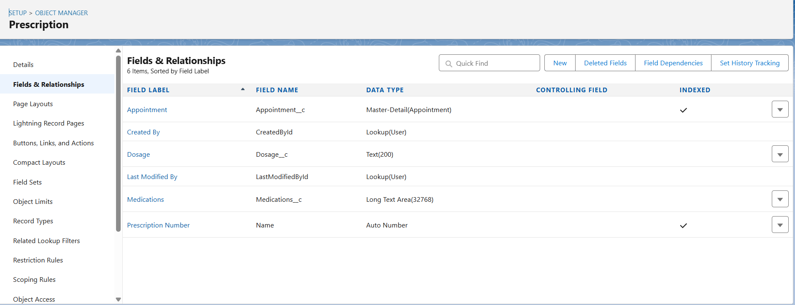

**Relationships**

* Patient ↔ Appointment → Lookup (One patient can have multiple appointments).
* Doctor ↔ Appointment → Lookup (One doctor can handle many appointments).
* Appointment ↔ Prescription → Master-Detail (Each appointment can have multiple prescriptions).



## **Record Types & Page Layouts**

* **Appointment__c** → Record Types for *OPD* and *Emergency*.
* **Page Layouts** → Separate layouts for doctors (focused on patient details) and receptionists (focused on scheduling).
* **Compact Layouts** → Quick view of upcoming appointment details.

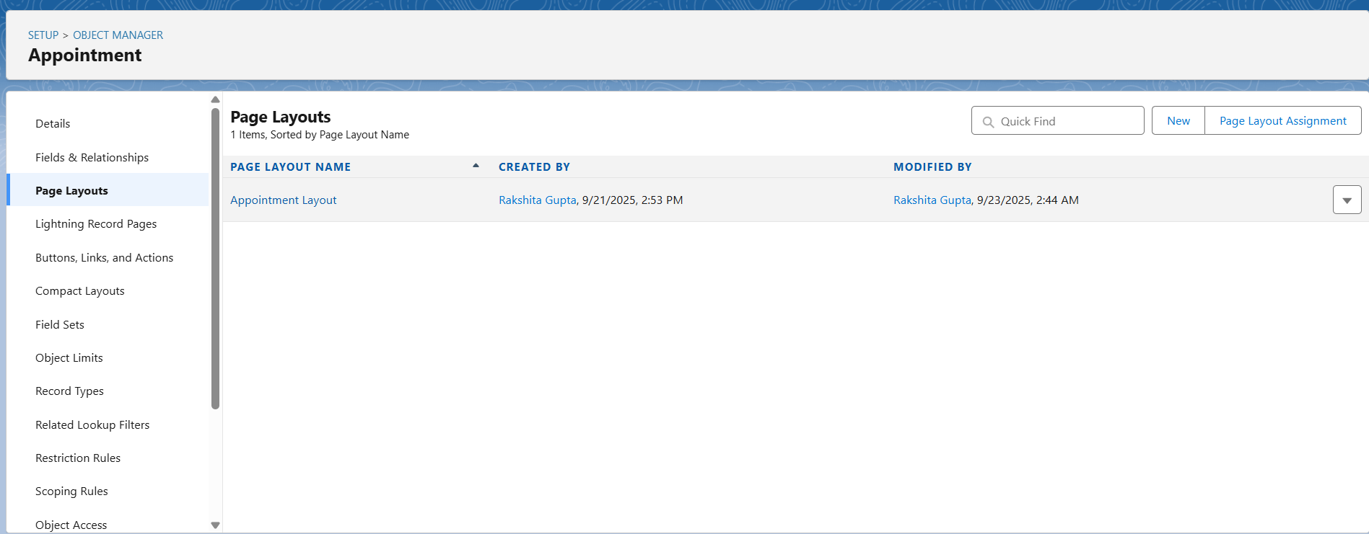

## **Data Model (ERD Diagram)**

## 

**Short Description**

This phase established the core data model of the CRM by creating objects, fields, and relationships to represent the hospital ecosystem. It ensures structured storage of patients, doctors, appointments, and prescriptions.

## **✅ Outcome of Phase 3**

* Core healthcare data model implemented.
* Relationships defined for smooth navigation.
* Ready for **automation and process flows** in the next phase.

# **Phase 4: Process Automation (Admin)**

👉 **Goal:** Automate key hospital workflows to reduce manual effort, avoid double-bookings, and improve patient communication.

**Automation Requirements**